EduGenie – Google Gemini Powered Learning Assistant
Project Design Phase-II
Data Flow Diagram & User Stories
Date | 28/09/2026
Team ID | SWTID-2026-EG01
Project Name | EduGenie
Submitted by: Rahul R | Mentor: Sasi B
Data Flow Diagram:
A Data Flow Diagram (DFD) is a traditional visual representation of the information flows within a system. It shows how data enters and leaves the system, what changes the information, and where data is stored. The diagram below traces a request from the learner through the FastAPI router to the local or cloud AI module and back to the result view.
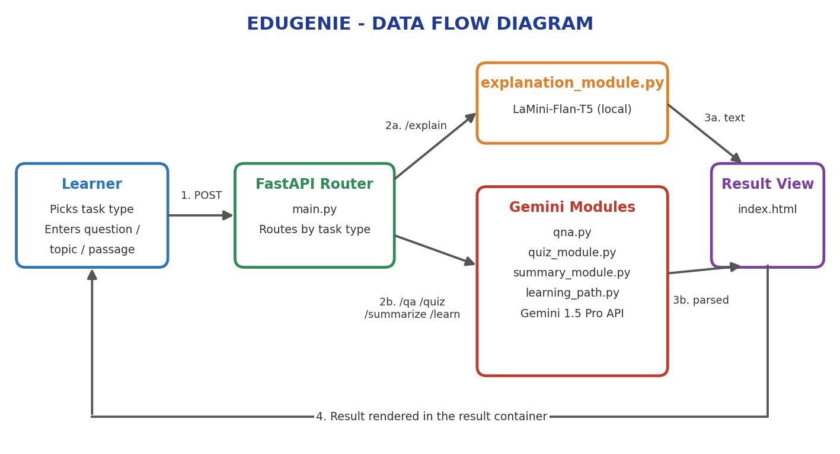
Data Flow Overview:
- Client (browser) → HTML form (templates/index.html) submits a task type (Explain / QnA / Quiz / Summary / Recommend Path) and input text
- FastAPI app (main.py) receives the POST request and routes it to the matching module
- Explanation requests → explanation_module.py → local LaMini-Flan-T5 model → simplified explanation returned
- QnA, Quiz, Summary, and Learning-Path requests → qna.py / quiz_module.py / summary_module.py / learning_path.py → Google Gemini 1.5 Pro API → structured response returned
- Response is rendered back into the HTML result container and displayed to the user in real time
User Stories
Use the below template to list all the user stories for the product.
User Type | User Story Number | User Story / Task | Acceptance Criteria | Priority | Release
Learner | USN-1 | As a user, I can ask a question and get a concise answer | Submitting a question on /qa returns a relevant, accurate answer | High | Sprint-1
Learner | USN-2 | As a user, I can request a simplified explanation of a concept | Submitting a concept on /explain returns an easy-to-read explanation | High | Sprint-1
Learner | USN-3 | As a user, I can generate a quiz from a topic or passage | Submitting text on /quiz returns 3 MCQs with 4 options each in valid JSON | High | Sprint-2
Learner | USN-4 | As a user, I can summarize a long passage | Submitting text on /summarize returns a concise, accurate summary | Medium | Sprint-2
Learner | USN-5 | As a user, I can request a personalized learning path for a topic | Submitting a topic on /learn/recommendations returns a beginner-to-advanced plan with resources | High | Sprint-3
Learner | USN-6 | As a user, I can select the task type from a dropdown on one page | The task dropdown correctly routes input to the matching module | Medium | Sprint-1
Learner | USN-7 | As a user, I see my result appear below the input box without a page reload | Form submission uses POST and updates the result area in real time | Medium | Sprint-3
Learner | USN-8 | As a user, I receive a clear message if the AI response fails or is invalid | Malformed AI output returns a readable error instead of a crash | Medium | Sprint-3

